***Reaching the Masses: The Journey Continues!***

***Emphasis: Equity & Justice***

***THE OFFERING APPEAL***

***Please make a recommitment offering in support of the Annie E. Walker Blackwell Observance. The funds will benefit Home and Overseas Missionary Projects.***

***“Every man shall give as he is able according to the blessings of the Lord.”***

**Remit Offerings to:**

**Your District President for remittance to:**

**Mrs. Rosetta Dunham**

**Executive Director**

**P.O. Box 26846**

**Charlotte, North Carolina 22821-6846**

**Program Prepared by:**

**Reverend Patricia “Patty” Surratt-Smith**

**Second Vice-President**

**Mrs. Sandra B. Crowder**

**International President**

***“Keep Everlasting at It”***

***Equity & Justice!***

***Annie E. Walker Blackwell***

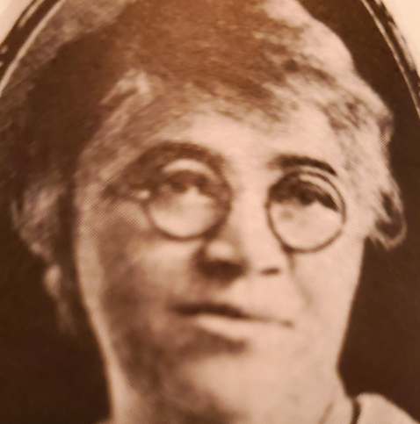

**A Visionary Missionary**

**December 8, 2024**

***(Suggestion: Use at a Local Church Missionary* *Meeting***

***or District Mass Meeting.)***

**“Reaching the Masses in An Ever-Changing World:**

**The Journey Continues!**

**Emphasis: Equity & Justice**

***ANNIE E. WALKER BLACKWELL***

***Equity & JUSTICE MEDITATION***

**Opening Hymn: Come Thou Fount of Every Blessing**

**Invocation**

**Scripture: Psalm 33:5**

**The Litany - (St. matthew 25:35-37; 40)**

**Leader:** for I was hungry and you gave Me food; I was thirsty and you gave Me drink; I was a stranger and you took Me in;

**People**: I *was* naked and you clothed Me; I was sick and you visited Me; I was in prison and you came to Me.

**Leader:** “Then the righteous will answer Him, saying, ‘Lord, when did we see You hungry and feed *You,* or thirsty and give *You* drink?

**ALL:** And the King will answer and say to them, ‘Assuredly, I say to you, inasmuch as you did *it* to one of the least of these My brethren, you did *it* to Me.’

**Meditation *(Short Message Equity & Justice):* Designated Mission educator or Missionary**

**Selection: GOODNESS OF GOD (CeCe Winans)**

[**https://youtu.be/9sE5kEnitqE?si=TOjTXLP57fVyPxEi**](https://youtu.be/9sE5kEnitqE?si=TOjTXLP57fVyPxEi)

**THE ANNIE E. WALKER BLACKWELL OFFERING**

**OUTREACH MISSION: (In conjunction with World Hunger)**

***Mission Educators, please sponsor a Food Drive in your community***

**The Closing hymn…………………….“Lift Him Up”**

**THE MISSIONARY BENEDICTION: God be merciful unto us and bless us and cause His face to shine upon us and give us peace.**

***ANNIE E. WALKER BLACKWELL***

**Remember The Leader**

**August 21, 1862 - December 7, 1922**

Corresponding Secretary of

Woman’s Home and Foreign Missionary Society, 1904-1922

Annie E. Walker Blackwell was born on August 21, 1862 in Chester South Carolina. She was educated in Scotia Seminary in Concord, North Carolina. On December 7, 1887, Annie married Rev. George Lincoln Blackwell, who later became a Bishop of the A.M.E. Zion Church, elected in 1908. During that period, Bishops did not appoint “Supervisors,” thus, she assumed the role as a “Vice President.” It was Mrs. Blackwell’s recommendation that laid the groundwork for the change in title from Vice-President to Supervisor.

At the General Conference of 1904, Mrs. Annie E. W. Blackwell was elected Corresponding Secretary of the W.H. &F.M. Society, a position she held for 18 years. Annie E. W. Blackwell was a visionary. She envisioned the economic potential of the society’s life membership program provided for in the constitution. As the result of her perseverance, the first persons were enrolled as life members at the Missionary Convention in 1906.

Annie Blackwell saw the need for additional training in Africa for young people. She envisioned a girl’s school that might equip them for greater service.

Annie E. W. Blackwell died on her thirty-fifth wedding anniversary, December 7, 1922, and was buried in Eden Cemetery, Philadelphia, Pennsylvania.

Her motto was **“Keep everlastingly at it”.**

