***Reaching the Masses: The Journey Continues!***

***Emphasis: Leadership & Legacy***

***THE OFFERING APPEAL***

***Please make a recommitment offering in support of the Annie E. Walker Blackwell Observance. The funds will benefit Home and Overseas Missionary Projects.***

***“Every man shall give as he is able according to the blessings of the Lord.”***

**Remit Offerings to:**

**Your District President for remittance to:**

**Mrs. Rosetta Dunham**

**Executive Director**

**P.O. Box 26846**

**Charlotte, North Carolina 22821-6846**

**Program Prepared by:**

**Reverend Patricia “Patty” Surratt-Smith**

**Connectional Second Vice-President**

**Mrs. Sandra B. Crowder**

**International President**

***“Keep Everlasting at It”***

***Leadership & Legacy!***

***Annie E. Walker Blackwell***

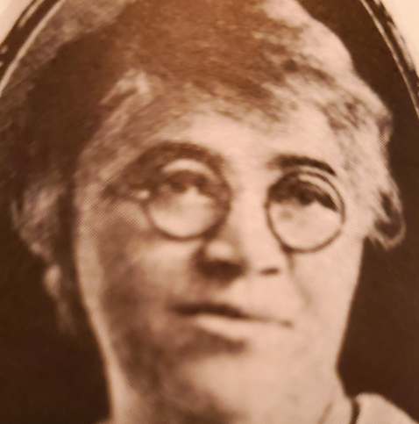

**A Visionary Missionary**

**December 7, 2025**

***(REMEMBERING YOUR LEADERSHIP & LEGACY)***

***(Suggestion: Use at a Local Church Missionary* *Meeting***

***or District Mass Meeting.)***

**“Reaching the Masses in An Ever-Changing World:**

**The Journey Continues!**

**Emphasis: Leadership & Legacy**

***ANNIE E. WALKER BLACKWELL***

***LEADERSHIP & LEGACY MEDITATION***

**Opening Hymn: “I Am Thine, O Lord”**

**Invocation: Come into this Place, O Lord, and Guide us through this service of worship. AMEN.**

**Scripture: Psalm 31:1-3 (KJV)**

**The Litany – Psalm 78:1-4 (KJV)**

**Leader:** Give Ear, O my people to my law; incline your ears to the words of my mouth.

**People**: I will open my mouth in a Parable. I will utter dark sayings of old.

**Leader:** Which we have heard and known, and our fathers have told us.

**ALL:** We will not hide THEM FROM their children, Showing to the generation to come the praises of the Lord, and his strength, and his wonderful works he hath done.

**Meditation *(****Short meditation on remembering Annie*

*W. BLACKWELL’S LEGACY):* **DESIGNATED Mission educator**

**or Missionary**

**Selection: Thank YOU, LORD (CHRISTINA BELL)** <https://youtu.be/T1pNXQBBWrs>

**THE ANNIE E. WALKER BLACKWELL OFFERING**

**OUTREACH MISSION: (*Mission Educators are asked to***

***contact and support an outreach ministry of your***

***choice in remembrance of Annie W. Blackwell’s Legacy)***

**The Closing hymn…………………….“Lift Him Up”**

**THE MISSIONARY BENEDICTION: God be merciful unto us and bless us and cause His face to shine upon us and give us peace.**

***ANNIE E. WALKER BLACKWELL***

**Remembering Her Leadership & Legacy**

**August 21, 1862 - December 7, 1922**

Corresponding Secretary of

Woman’s Home and Foreign Missionary Society, 1904-1922

Annie E. Walker Blackwell was born on August 21, 1862 in Chester South Carolina. She was educated in Scotia Seminary in Concord, North Carolina. On December 7, 1887, Annie married Rev. George Lincoln Blackwell, who later became a Bishop of the A.M.E. Zion Church, elected in 1908. During that period, Bishops did not appoint “Supervisors,” thus, she assumed the role as a “Vice President.” It was Mrs. Blackwell’s recommendation that laid the groundwork for the change in title from Vice-President to Supervisor.

At the General Conference of 1904, Mrs. Annie E. W. Blackwell was elected Corresponding Secretary of the W.H. &F.M. Society, a position she held for 18 years. Annie E. W. Blackwell was a visionary. She envisioned the economic potential of the society’s life membership program provided for in the constitution. As the result of her perseverance, the first persons were enrolled as life members at the Missionary Convention in 1906.

Annie Blackwell saw the need for additional training in Africa for young people. She envisioned a girl’s school that might equip them for greater service.

Annie E. W. Blackwell died on her thirty-fifth wedding anniversary, December 7, 1922, and was buried in Eden Cemetery, Philadelphia, Pennsylvania.

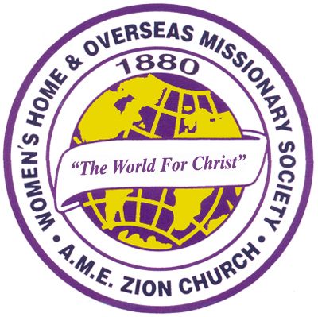Her motto was **“Keep everlastingly at it”.**