HISTORY OF ANNA L. ANDERSON DAY

Bishop William Jacob Walls stated in his book, The African Methodist Episcopal Zion Church: Reality of the Black Church “...In 1943 the [WHOMS] convention voted that October be set aside as Life Members Month in memory of Anna Lucille Anderson. It was she who in 1916 suggested the plan adopted for the foundation of the Life Members Council.

She worked tirelessly for its salvation and fundamental rootage and watched it come to fruition in 1935 at the Convention held in Indianapolis.” The Life Members Council is designated as the Educational Arm of the Women’s Home and Overseas Missionary Society. Membership in the Council enables the Society to support the ministries on the Tree of Hope. Because of your investment and continued support, financial assistance is given to Hood Theological Seminary, Livingstone College, Clinton College, Lomax-Hannon Junior College, A.M.E. Zion University, and Hood Speaks Theological Seminary. Funds are also used to provide grants and scholarships to students attending these institutions, to pay stipends for field workers, to fund Missionary Education Leadership Training in America and overseas, and to support the general operation of the Society.

When we see and read about the contributions made by the Council, we can see how important it is for every member of Zion to become a Life Member, Honorary Life Member, Life Matron, Life Patron, or Heart for Overseas Missions supporter.

Program prepared by: Mrs. Joy Foster, Connectional LM Chairman and the Mentor/Mentee Initiative of the Life Members Council.

Please send Anna L. Anderson contributions to the District President for remittance to the WH&OMS, Mrs. Rosetta Dunham, Executive Director -P O. Box 26846, Charlotte, NC 28221

Women’s Home and Overseas Missionary Society
Anna L. Anderson Day October 2025
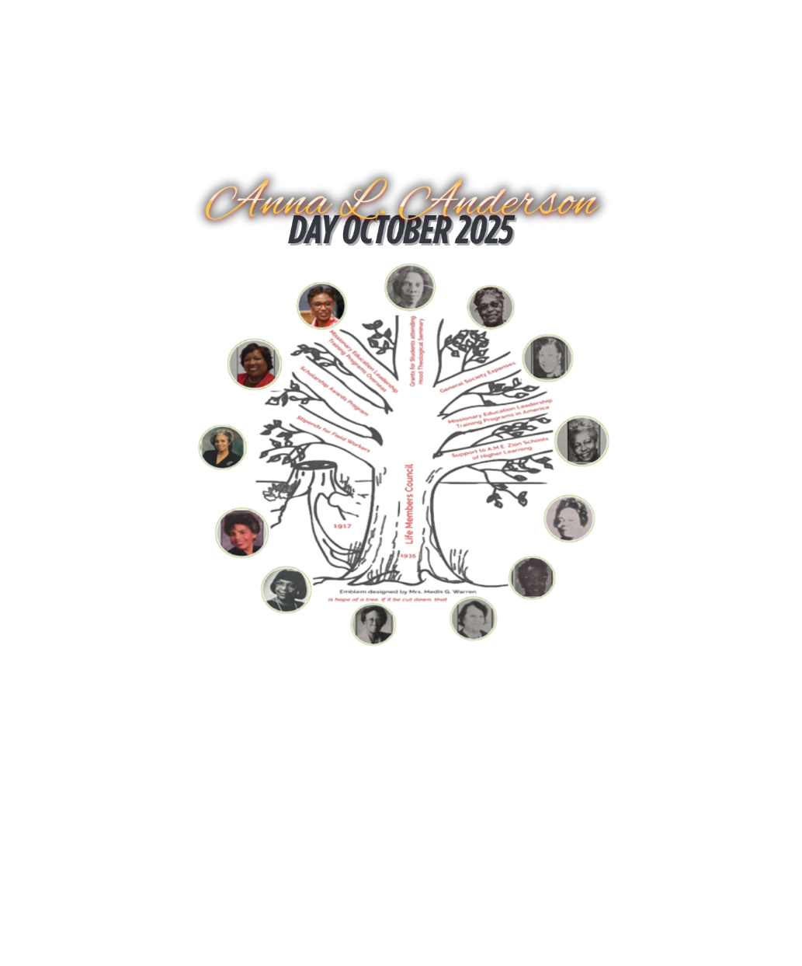

2023 – 2027 QUADRENNIAL THEME:
“REACHING THE MASSES IN
AN EVER-CHANGING WORLD
LEADERSHIP & LEGACY
Mrs. Joy Foster, Connectional Chairman,
Life Members Council
Mrs. Sandra B. Crowder, International President
THE CALL TO WORSHIP
Stand up, oh ye people, Stand up! The call has been given to lead; To lead in a manner pleasing to God, reaching the masses in an ever-changing world to leave a legacy that inspires generations to come. AMEN.
THE INVOCATION
Heavenly Father we invoke your presence on this day as we honor the legacy of Anna L. Anderson the visionary for the Life Members Council. Let her vision continue throughout Zion and your spirit guide us today and for years to come. AMEN.
THE AFFIRMATION OF FAITH
THE HYMN OF PRAISE
Traditional- “Lead Me, Guide Me.”
Contemporary- “A Leader’s Faith” by LaRue Howard
THE LITANY OF LEADERSHIP AND LEGACY
Leader: Generation after generation stands in awe of your work; each one tells stories of your mighty acts (Psalms 145:4 MSG)
People: Help us to understand the need to intentionally grow in leadership and to leave a legacy
Leader: From 1935 to 2025, the Life Members Council continues to be the “Educational Arm” of the Women’s Home and Overseas Missionary Society
All: We thank you God for branches on the Tree of Hope which remain in season and flourish throughout the ages. We thank you God for 90 years of “Throwing out the Lifeline” leaving a legacy for future Missionaries. AMEN.
SCRIPTURE READING 2 Timothy 2:2
THE PRAYER FOR LEADERSHIP AND LEGACY
Almighty God, we are filled with gratitude for all that you have done for us. Christ’s sacrifice serves as our Sanctuary. As your humble Servants, we yearn to draw closer to you. We wholeheartedly rely on you to equip us to be the Servants, you purposed us to be. Grant every Servant the strength and guidance to endure hardships without growing weary, but instead, to rely solely on you. Provide us with the courage to share our stories about your love, grace and mercy that have guided us through. As we share our testimonies of your faithfulness with others, let those stories linger in their minds and hearts, serving as a legacy of our service to you. Amen

THE SERMONIC SELECTION
THE MESSAGE OF LEADERSHIP AND LEGACY
THE INVITATIONAL HYMN & CALL TO DISCIPLESHIP
THE ANNA L. ANDERSON DAY OFFERING APPEAL
THE MISSIONARY BENEDICTION
God be merciful unto us and bless us and cause His face to shine upon us and give us peace. AMEN.

