Women’s Home and Overseas
Missionary Society

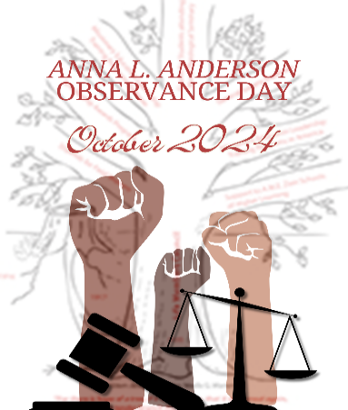
2023 – 2027 QUADRENNIAL THEME:
“REACHING THE MASSES IN AN
EVER-CHANGING WORLD”
EQUITY & JUSTICE

Mrs. Joy Foster, Connectional Chairman,
Life Members Council

Mrs. Sandra B. Crowder,
International President

THE CALL TO WORSHIP
Oh, come give thanks unto to the Lord for He is worthy to be praised. We ask, Lord, that you come into this place and give us peace and understanding. Although we find that equity and justice does not change over a day, month and sometimes years, we know your lover endures forever. AMEN.

THE INVOCATION
THE AFFIRMATION OF FAITH
THE HYMN OF PRAISE Traditional - Amazing Grace Hymn # 501
Contemporary- Worship & Justice by William Murphy

THE LITANY FOR EQUITY & JUSTICE
Leader: Blessed Is he who meets the needs of God’s people.
People: God’s people need to be feed, are thirsty, naked, and sick.
Leader: Blessed is he who shares God’s love and kindness.
People: God’s people are wrongfully imprisoned and need justice.
ALL: Blessed is he who walk humbly with God in faith, helping
to transform the lives of God’s people who need Equity and Justice

THE SCRIPTURE READING Micah 6:8 NIV or MSG

THE PRAYER FOR EQUITY
Heavenly Father, thank you for creating all of humanity in your image. Your love for us is unfathomable. Father God, give us a desire to love you, as you love us and our neighbors as ourselves. Please circumcise the hearts of your people and give us a yearning, regardless of race, ethnicity, creed, or gender, to promote equity and justice in this broken world. Lord, raise up individuals and leaders
with ministries to become advocates for the vulnerable and marginalized populations. Loving God, give us a burning desire to do
your will and let it begin with me. It is in Jesus’ name we pray. Amen.

THE PRAYER FOR JUSTICE
Dear Heavenly Father, we come before you as your word declares of the love for justice and not forsaking your children. We pray for all members of society who have been unfairly and falsely accused of injustices. Lord, please provide our communities with equitable resources to combat evil and break the power of the oppressed in local and national politics. Please bless us to be involved with decision making politics that would bring justice for our children, the community and the needy. In Jesus name we pray. Amen

EQUITY & JUSTICE MOMENT 2024
We aim to live in a world that recognizes and supports the differences, and inequities that people of color continue to face post Covid. People of color who represent the Global Majority are disenfranchised from quality healthcare, housing, education, law enforcement and access to equitable employment. We must be unwavering in our fight for justice around the world by devoting ourselves to human rights. We all have a role in building a more just world.

THE SERMONIC SELECTION
THE MESSAGE OF EQUITY & JUSTICE
THE INVITATIONAL HYMN/CALL TO DISCHIPLESHIP
THE OFFERING
THE MISSIONARY BENEDICTION
“God be merciful unto us and bless us and us and cause His face to shine upon us and give us peace. AMEN.”

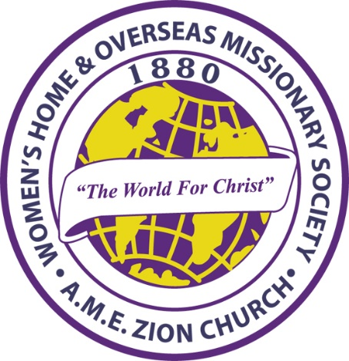

HISTORY OF ANNA L. ANDERSON DAY

Bishop William Jacob Walls stated in his book, The African Methodist Episcopal Zion Church: Reality of the Black Church “...In 1943 the [WHOMS] convention voted that October be set aside as Life Members Month in memory of Anna Lucille Anderson. It was she, who in 1916 suggested the plan adopted for the foundation of the Life Members Council.

She worked tirelessly for its salvation and fundamental rootage and watched it come to fruition in 1935 at the Convention held in Indianapolis.” The Life Members Council is designated as the Educational Arm of the Women’s Home and Overseas Missionary Society. Membership in the Council enables the Society to support the ministries on the Tree of Hope. Because of your investment and
continued support, financial assistance is given to Hood Theological Seminary, Livingstone College, Clinton College, Lomax-Hannon Junior College, A.M.E. Zion University, and Hood Speaks Theological Seminary. Funds are also used to provide grants and scholarships to students attending these institutions, to pay stipends for field workers, to fund Missionary Education Leadership Training in America and overseas, and to support the general operation of the Society.

When we see and read about the contributions made by the Council, we can see how important it is for every member of Zion to become a Life Member, Honorary Life Member, Life Matron, Life Patron, or Heart for Overseas Missions supporter.

Program prepared by: Mrs. Joy Foster, Connectional LM Chairman
and the Mentor/Mentee Initiative of the Life Members Council.

Please send Anna L. Anderson contributions to the District President for remittance to the WH&OMS, Mrs. Rosetta Dunham, Executive Director, P.O. Box 26846, Charlotte, NC 28221

