Celebrating the 145th Anniversary of
The Women’s Home and
Overseas Missionary Society

1880-2025



May 2025

Anniversary Emphasis:
A Continuous Journey for Equity and Justice

Quadrennial Theme:
Reaching the Masses in an Ever-Changing World, the Journey Continues
Self-Care and Wellness, Equity and Justice,
Leadership and Legacy , Empathy and Compassion

Mrs. Sandra Crowder, International President

The 145th Anniversary
1880-2025
Women’s Home and Overseas Missionary Society

The Call to Worship: "I will extol the LORD at all times; his praise will always be on my lips. My soul will boast in the LORD; let the afflicted hear and rejoice. Glorify the LORD with me; let us exalt his name together." Psalm 34:1-3 (NIV)

The Opening Hymn “Lift Him Up”

The Scripture Proverbs 31:8-9

The Prayer (unison) God, our creator, and the ground of our being, we give you thanks for all of the blessings of this life, especially for the gift of each other and our work. Every person is a treasure, every life a sacred gift. May the work we do diminish the chasm of disparity and bring about greater justice and equity. Amen.

The Litany:
Leader: O God, you formed all humanity to bear your divine image, and you intend for everyone to live together in harmonious dignity. Break down the walls that separate us by color, culture, or religion.
People: Grant us, Lord God, a vision of your world as your love would have it.
Leader: God, open our eyes that we may see the needs of others; open our ears that we may hear their cries.
People: Grant us, Lord God, a vision of your world as your love would have it.
Leader: God, open our hearts that we may recognize our own unjust practices in our families and our communities. Purge the privileged of their sense of superiority and lead us to foster communities of equity and diversity.
People: Grant us, Lord God, a vision of your world as your love would have it.

Leader: God, let us not be afraid to defend the poor because of the anger of the rich. Let us not be afraid to defend the weak because of the anger of the strong,
People: Grant us, Lord God, a vision of your world as your love would have it.
Leader: God, fill our hearts, we pray, with the fire of your love and kindle in us desire for the just advancement of all without prejudice.
People: Grant us, Lord God, a vision of your world as your love would have it.
Leader: God, guide us to nurture a society that embodies reconciliation and cooperation among all, for the sake of the one who personifies your love.
All: Grant us, through our Lord Jesus Christ, your Son, who lives and reigns with you, the courage to open our mouths to speak up and about injustices. Meld us with others to work for racial equity and inclusion for all people. Mold us into those who work for a world where peace is built with justice, and justice is guided by love. Amen.
The History of the W.H.&O.M. Society
(See Cherishing the Legacy, Continuing the Journey)

The Introduction of the Speaker

The Song of Preparation “We Shall Not Be Moved”

The Anniversary Message Speaker:
“A Continuous Journey for Equity and Justice”

The Call to Christian Discipleship

The Invitational Hymn “We Shall Overcome”

The Anniversary Offering Offertory

The Missionary Benediction “God Be merciful unto us, and bless us, and cause His face to shine upon us, and give us peace.” Amen.
A Continuous Journey of Equity and Justice:
Host Equity and Justice Forums

“Injustice anywhere is a threat to justice everywhere.”
― Martin Luther King Jr.

Hosting Equity and Justice Forums is a significant way to continue our commitment to this component. Use your local missionary meetings, district mass meetings, conference sessions, or Episcopal institutes to provide a space and place for listening, dialogue, and greater understanding about ideas for dealing with current challenges facing our nation and planning for a better future. Use Equity and Justice Forums to speak up, stand up, and act on race, gender, socioeconomic status, health, educational, and political
disparities.
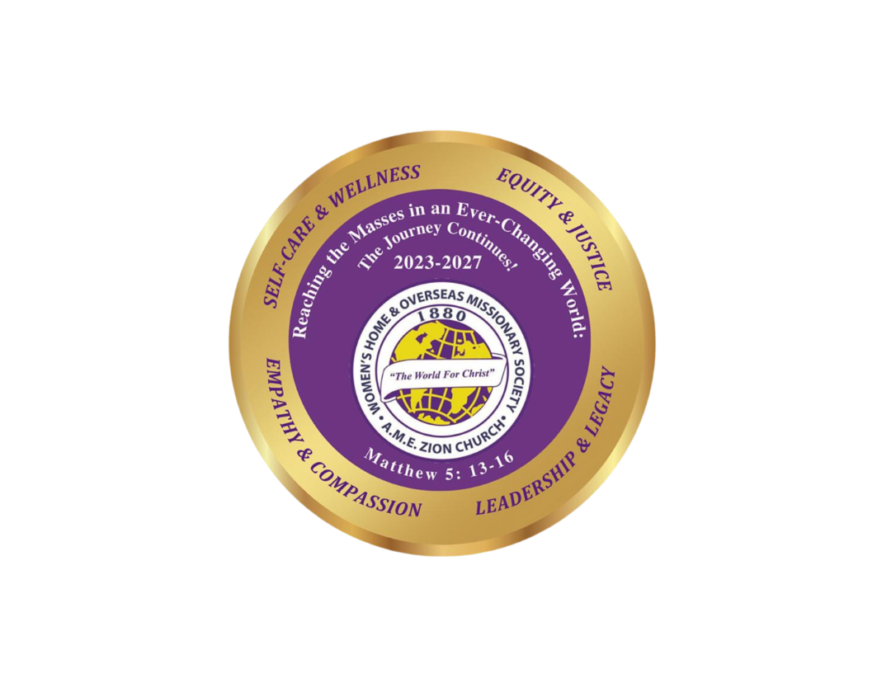
Program was prepared by Mrs. Sandra B. Crowder,
18th International President

Please remit all 145th W.H.&O.M. Society Anniversary
financial support to the District President to be sent to
Mrs. Rosetta Dunham, Executive Director,
P.O. Box 26846 - Charlotte, NC 28221-6846

