**Young Adult Missionary Society ~ Historical Review**

The vision of the Young Adult Missionary Society began in August 1975 when Dr. Willa Mae Rice, then General President of the WH&OM Society, brought a resolution to the 18th Quadrennial Convention held in Los Angeles, CA to establish a department for women ages 27-40. The resolution was not adopted, but in 1979 at the 19th Quadrennial Convention held in Miami, FL, the delegates voted to bring the Y.A.M.S. in under the umbrella of the Parent Body.

However, in 1983 at the 20th Quadrennial Convention in New Orleans, LA, the YAM Society was adopted as the sixth Department of the Women’s Home and Overseas Missionary Society. Dr. Adlise I. Porter, the Second Vice - President, was appointed Coordinator of the Department by the Convention. Through her spiritual gifts, Dr. Porter developed the structure of the Department which included writing the operational guidelines for the Department’s Thematic Bible Studies, Social Concerns Projects, motto, colors, and theme song. Prior to the 22nd Quadrennial Convention held in New Orleans, LA, the YA.M.S. Anniversary Day was called “Willa Mae Rice Day”. It was during this Convention that a resolution was adopted to change “Willa Mae Rice Day” to “Founders’ Day” to honor Dr. Rice as Founder and Dr. Porter as the Organizing Coordinator.

In 1991, at the 22nd Quadrennial Convention, Mrs. Joann B. Holmes became the first elected General Coordinator. During the 23rd Quadrennial meeting, a resolution was adopted to change the ages of Y.A.M.S from 27-40 to 22-40. To chart the course of the Y.A.M.S. into the 21st century, Mrs. Sandra B. Crowder was elected the 3rd General Coordinator at the 24th Quadrennial Convention in Dallas, TX. In 2007, at the 26th Quadrennial Convention in Orlando, FL, Mrs. Dawn L. Walker was elected the 4th General Coordinator of the Y.A.M.S. In Orlando, FL, Dr. Joy L. Kennedy, was elected the 5th General Coordinator. During the 29th Quadrennial Convention, a resolution passed changing the title from General Coordinator to Connectional Coordinator. Recently, at the 30th Quadrennial Convention, Ms. Karlease M. Smalls was elected as the 6th Connectional Coordinator of Y.A.M.S., in New Orleans, LA.

**Y.A.M.S. MOTTO**

“With hearts and hands,

We reach up to God for strength and direction.

We reach out to love and touch others.

We reach down to lift fallen humanity.”

Please send all financial support for Founders’ Day to the District President for remittance to

Mrs. Rosetta J. Dunham, Executive Director

P.O. Box 26846

Charlotte, NC 28221

*Young Adult Missionary Society*

*41st Anniversary 1983-2024*

*Founders’ Day Observance*

**Longsuffering**

**Acceptance**

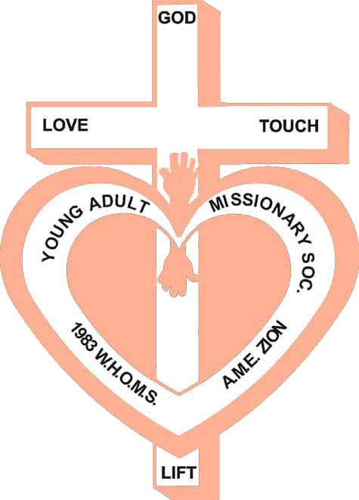

**Hope**

**Freedom**

**Love**

**Harmony**

**Security**

**Respect**

**Unity**

**Faith**

**Peace**

**Patience**

November 10, 2024

2023-2027 Quadrennial Theme:

Reaching the Masses in an Ever-Changing World:

The Journey Continues!

**~ Equity & Justice ~**

Women’s Home and Overseas Missionary Society

The African Methodist Episcopal Zion Church

**(Your Name)**

**District Coordinator**

**Ms. Karlease Smalls**

**Connectional Coordinator of the Y.A.M.S.**

**Mrs. Sandra Crowder**

**International President of the WH&OMS**

**Processional**

**Order of Worship**

**The Gloria Patri**

**The Affirmation of Faith**

**Call to Worship** *Revelation 15:3 (NLT)*

And they were singing the song of Moses, the servant of God, and the song of the Lamb: “Great and marvelous are your works, O Lord God, the Almighty. Just and true are your ways, O King of the nations.

**Invocation**

**Hymn of Praise** “*Pass Me Not, O Gentle Saviour*” (BH #291)

**Responsive Reading** *Psalm 37: 23-29 (NLT)*

**Leader**: The Lord directs the steps of the godly. He delights in every detail of their lives. Though they stumble, they will never fall, for the Lord holds them by the hand.

**People:** Once I was young, and now I am old. Yet I have never seen the godly abandoned or their children begging for bread.

**Leader:** The godly always gives generous loans to others, and their children are a blessing.

**People:** Turn from evil and do good, and you will live in the land forever.

**All**: For the Lord loves justice, and he will never abandon the godly. He will keep them safe forever, but the children of the wicked will die. The godly will possess the land and will live there forever.

**The Scripture Lesson**: *Isaiah 61:1-9 (NLT)*

**Prayer**

**Choral Selection**: Bishop Hezekiah Walker “Faithful Is Our God”

**Founders’ Day Tributes to Dr. Willa Mae Rice**

**and Dr. Adlise Ivey Porter**

**The Offering/The Offertory**

**Introduction of the Founders’ Day Messenger**

**Sermonic Selection**: “My Hope Is Built” (BH#286)

**Founders’ Day Message**:

Theme: “Equity & Justice”

**Invitation to Christian Discipleship**

**Invitational Hymn**  “Tis So Sweet to Trust in Jesus” (BH #508)

**Missionary Benediction**

“God be merciful unto us, and bless us, and cause His face to shine upon us and give us peace.” Amen.