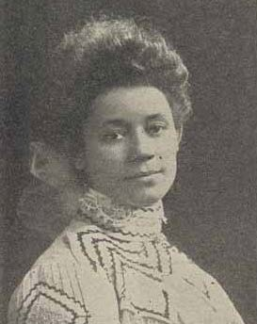**Mrs. Marie Louise Clay Clinton**

(1871–1934)

Mrs. Marie Louise Clay Clinton was the organizer and first Superintendent of the Buds of Promise Juvenile Missionary Society. She was born in Huntsville, Alabama in1871.

Mrs. Clinton was the wife of Bishop George Wylie Clinton. She loved children and, having none of her own, she dedicated her life to children’s work.

She understood the importance of Christian training for very young children. Mrs. Clinton worked diligently to see that children be included as part of the General Missionary Society.

In 1904, her request to include the children as an organized department of the Missionary Society was taken to the General Conference in St. Louis, Missouri. It was then that the department was adopted and, through her efforts, became permanently known as the “Buds of Promise” department in 1908. Mrs. Clinton served as the General Superintendent for 28 years (until 1932) and remained an enthusiastic worker until her death in1934.

In 1951, the Missionary Convention in Wilmington, North Carolina voted that a day be set aside in order to honor the founder of The Buds of Promise Department. Because of Mrs. Marie L. Clay Clinton’s love and devotion to children and work of missions, the fourth Sunday of January is recognized as “Marie L. Clinton Day.”

**1904**

MARIE L. CLINTON DAY

Buds of Promise Juvenile Missionary Society

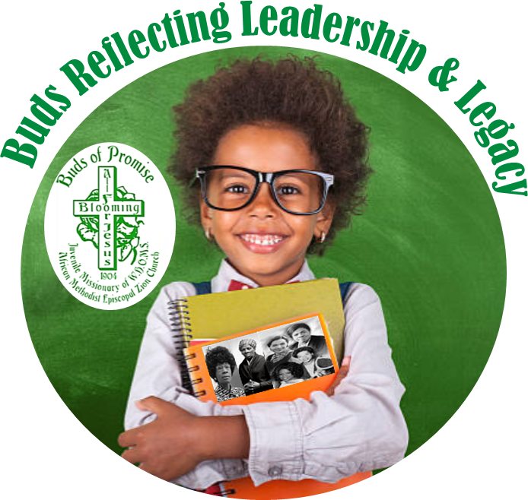

**2026**

*Photo from Progressive Missions in the South and Addresses with Illustrations and Sketches of Missionary Workers and*

*Ministers and Bishops’ Wives, Electronic Edition, Sara J. Duncan, M.A.*

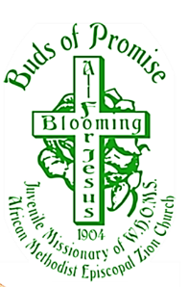Buds Information

**Motto:** “Blooming All For Jesus”

**Colors:** Green (***growth***) & White (***purity***)

**Slogan: The Three B’s:**

We **Build** with Zion,

We **Belong** to Zion,

We **Believe** in Zion.

**Pledge:** To be reverent to God, useful to man, do

God’s will and strengthen my faith with prayer.

**Buds Hymn:** “I Would Be True”

**Buds Theme Song:** “Blooming All For Jesus”

**SEND OFFERING TO:**

Mrs. Rosetta Dunham, Executive Secretary, W.H.&O.M.S.

***Through*** your District President to**:**

**Post Office Box 26846**, **Charlotte, NC 28221-6846**

Make checks payable to W.H.&O.M.S

*Quadrennial Focus*

REACHING THE MASSES IN AN

EVER-CHANGING WORLD - THE JOURNEY CONTINUES:

Leadership & Legacy

**Sunday, January 25, 2026**

Mrs. April C. Davis, Connectional Superintendent

Buds of Promise Juvenile Missionary Society

Mrs. Sandra B. Crowder, International President

Women’s Home & Overseas Missionary Society

The African Methodist Episcopal Zion Church

**ORDER OF SERVICE**

Prelude Musician

Procession of Symbols #674 “I Would Be True”

*(Cross, American Flag, Christian Flag, Bible, Hymnal, Buds Banner)*

Procession of Buds of Promise

Call to Worship

Dear God, we thank you for today and every day for leading and covering us with your love and care. We thank you for your son, Jesus Christ, who is a constant example of leadership and how we should treat one another. Thank you, God, for our founder, Marie L. Clinton, for we are her legacy to Zion as missionaries blooming all for Jesus! We pray for your presence in our service today, and your presence around the world for those who are sick and need your help. We love you, God and ask all these blessings in the name of Jesus Christ. Amen.

Choral Response Buds of Promise

Buds Hymn #676 “Blooming All For Jesus”

The Litany

**Leader: Jesus called a little child to him.**

People: We praise God for children.

**Leader: He stood the child before the followers.**

**Then he said, “I tell you the truth.”**

People: We praise God for truth.

**Leader: You must change and become like little children.**

People: We praise God for grace.

**ALL: If you don’t do this, you will never enter the**

**kingdom. Amen.**

Gloria Patri #702

Apostles’ Creed #705

Scripture

*“You are young, but do not let anyone treat you as if you were not important. Be an example to show the believers how they should live. Show them with your words, with the way you live, with your love, with your faith, and with your pure life.”*

1 Timothy 4:12, Int’l Children’s Bible

Prayer

Choral Response

Selection Buds of Promise

Remembering our Founder Mrs. Marie L. Clinton

Buds Information Buds Motto ~ Slogan ~ Pledge

Song of Preparation Choir

Buds Mini-Message **“Reflecting Leadership and Legacy”**

Offering/Offertory

Closing Selection Buds of Promise

Remarks Superintendent of Buds

Pastor

Missionary Benediction:

*God be merciful unto us and bless us and cause*

*His face to shine upon us and give us peace. Amen.*

**“Reflecting Leadership and Legacy”**

On today, we remember and honor the founder of the Buds of Promise Juvenile Missionary Society, Mrs. Marie Louise Clay Clinton. Her love for children, vision and leadership ensured the establishment of the Buds of Promise of the WH&OMS. And as Buds, we are the legacy of Mrs. Clinton to be leaders and create a legacy of our own as missionaries from young and senior impacting the world positively through missions. For we believe, there is a Bud is every missionary. Our WH&OMS 3rd component ‘Reaching the Masses in an Ever-Changing World - The Journey Continues: Leadership and Legacy” is a call to remember our purpose as missionaries, especially young missionaries, Buds.

Have you ever stopped to view your reflection in a mirror? The mirror provides an unfiltered image of you in good or bad light. As children/Buds blooming all for Jesus, we are charged by God to reflect good light. Our scripture says in 1 Timothy 4:12, *“You are young, but do not let anyone treat you as if you were not important. Be an example to show the believers how they should live.”* Or in other words, no matter your age you can be an example; and reflect God’s love! And the verse continues on to tells us how, by showing “…*them with your words, with the way you live, with your love, with your faith, and with your pure life.”* So, as you awake each morning to prepare for the day by brushing your teeth, washing your body, brushing your hair and putting on clothes, remember to faithfully pray for God’s protection and love! Check your reflection before you leave your home or residence. It should reflect you as one prepared to kind and loving to others when others may not be kind or loving to you. For God sees all and will reward your faithfulness. For your reflection has the ability to lead and change the people you come in contact with you on the bus, in school and throughout your day. This will be your legacy of how you are remembered…so be a Bud who reflects good leadership and leaves a good legacy where ever you go.