**Adults**: May they value education and see themselves as an important part of their nation. Bless them to choose and prepare for careers and vocations that enrich their lives and the lives of others.

***Youth****: As we set personal and career goals, give us the knowledge and capability to achieve them. Help us to aim high, embrace good health, live by moral principles, have respect for life and property, and have a desire to serve others.*

**Adults**: May they feel connected to every village and nation of the world, and may they understand the importance of participating in many arenas of life.

***Youth****: God of our past, present, and future, let us see visions, discern problems, and search for solutions. Make us and shape us into strong African American men and women.*

Benediction

**Youth Missionary Society Facts**

* The Young Woman’s Home and Foreign Missionary society was organized in 1909. It was approved and enthusiastically adopted in 1912 as the third branch of the Missionary Society.
* The Y Branch name changed to the Young Woman’s Home and Overseas Missionary Society in 1979.
* In 1999, legislation was introduced to change the name to the Youth Missionary society to assure that the scope and thrust of the ministry be inclusive of young women as well as young men.
* The colors are blue and gold. Blue stands for truth, loyalty, the uncompromising ideals, and strength of character. Gold, like the sun, represents heaven, honor and the glowing radiant life full of energy that always disperses the love of God.
* The watchword is “Christ for Every Youth, Every Youth for Christ”.
* Each quadrennium, we are to hold the Dorothy S. Johnson Y Retreat for the continued development of our Youth of the AME Zion Church.
* “Victory Day” is observed the Sunday closest to January 12th the birthday of our founder, Miss Victoria Richardson.

**Youth Missionary Society**

**114th Year Anniversary**

Women’s Home & Overseas Missionary Society

**“Passing the Baton: Who’s Up NEXT?”**

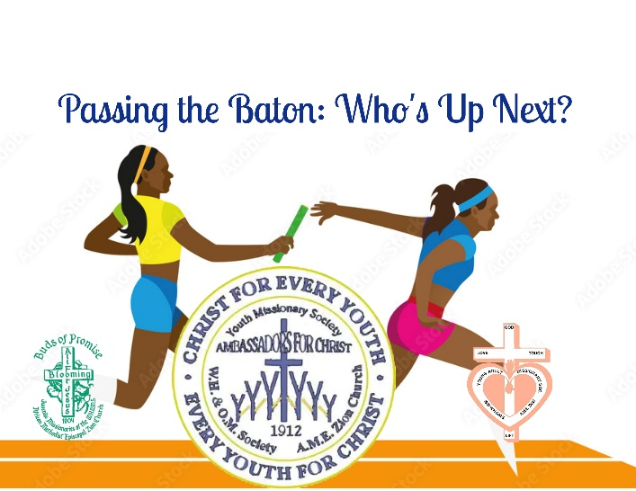**Sunday, January 11, 2026**

“Reaching the Masses in an Everchanging World: The Journey Continues

Leadership and Legacy”

**Prepared by Ms. Melva Polk Wright,**

**Connectional Secretary, Youth Missionary Society**

**Mrs. Sandra B. Crowder, International President**

**Women’s Home & Overseas Missionary Society**

**African Methodist Episcopal Zion Church**

Sunday Worship Experience

**“Passing the Baton: Who’s Up Next?”**

Call to Worship

“This is your day and we will praise you! This is your day and we will declare your name! This is your day, and we will worship you in spirt and in truth! Amen! Amen! Amen!

Opening Selection “Lord Prepare Me” West Angeles COGIC

Responsive Reading Led by a Youth

Leader: Teach us oh Lord the ways of thy statutes.

*People****: And I shall keep them until the end.***

Leader: Just give me understanding and I will keep they law.

***People: I shall observe them with my whole heart.***

***Altogether: Oh God, give us willing hearts to serve You!***

Affirmation of Faith Led by A Youth

Scripture Reading: Numbers 27:15-23 Led by A Youth

Prayer Led by A Youth

Selection “You Covered Me” Donald Lawrence

Offertory & Offertory Response A Youth

Youth Missionary Society Facts A Youth

Musical Selection “For the Rest of My Life” The Victorious Army ATL

Morning Message “Passing the Baton: Who’s Up Next?” *A Senior Y or Young Adult

Invitation to Christian Discipleship



Rite of Passage Litany for Youth

**Adults**: God, bless our youth that they may grow into men and women who honor you and who reflect the best of their families and communities.

***Youth****: As we experience the difficult task of becoming adults, guide us in the pursuit of faith, identity, and purpose.*

**Adults**: Above all may they come to know you and love you with all their hearts, minds, and souls. Let them know that you are always with them, helping them fulfill the plan which you have designed for their lives. May they keep your commandments and search out your will.

***Youth****: Wherever life takes us, may we never cease to praise you, to pray, and to study your Holy Word.*

**Adults**: God, save them from negative self-images, from feelings of hopelessness, and from peer pressure that contradicts the values which their families and churches have instilled in them.

***Youth****: As Jesus increased in wisdom and favor, grant that we as youth may also attain spiritual and human maturity.*

**Adults**: May they understand the responsibility and sensitivity necessary to become a friend, a leader, a spouse, and a parent.

***Youth****: Lord, give us role models and mentors. Grant us spiritual immunity from the brokenness and meanness of life. Help us to develop good relationships with others.*

**Adults**: May they acquire knowledge of their ancestry, master contemporary life skills, and understand the multicultural dimensions of our world.

***Youth****: May we begin the adult journey by remembering the history of their people. May we travel with confidence*.