The Offertory

The Missionary Benediction “God Be merciful unto us, and bless us, and cause His face to shine upon us, and give us peace.” Amen.

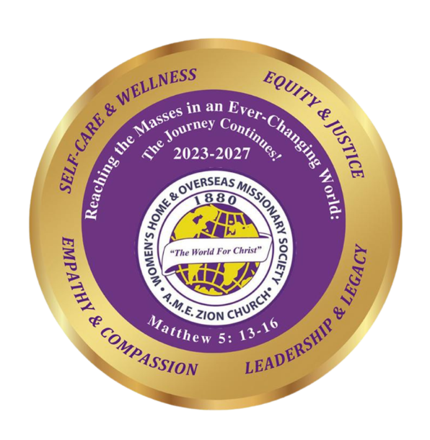

Leadership is not just a position—it is a purpose.
It is the courage to stand, the wisdom to guide,
and the faith to trust God along the way, so lead with faith,
serve with love and walk with integrity.
When your work is done, your legacy will live on
in those who rise because you did.

Program was prepared by Mrs. Sandra B. Crowder,
18th International President

Please remit all 146th W.H.&O.M. Society Anniversary
financial support to the District President to be sent to
Mrs. Rosetta Dunham, WH&OMS Executive Director,
P.O. Box 26846 - Charlotte, NC 28221-6846

Celebrating the 146th Anniversary of
The Women’s Home and
Overseas Missionary Society

1880 - 2026

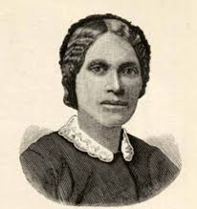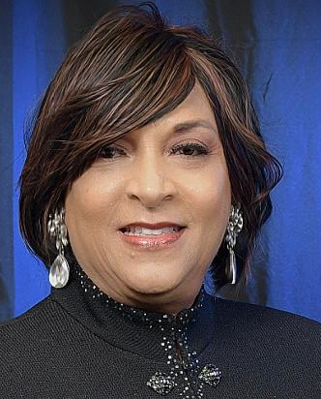
1ST GENERAL PRES. 18TH INTERNATIONAL PRES.
MARY TALBOT JONES SANDRA B. CROWDER

May 2026

Anniversary Emphasis:
“PASSING THE MANTLE:
LEADERSHIP THAT MULTIPLIES”

Quadrennial Theme:
Reaching the Masses in an Ever-Changing World,
the Journey Continues
Self-Care and Wellness, Equity and Justice,
Leadership and Legacy, Empathy and Compassion

Mrs. Sandra B. Crowder, International President

The 146th WH&OMS Anniversary
1880-2026

The Call to Worship: Give thanks to the Lord, for God is good. We gather to honor God and to renew our commitment to faithful leadership. We answer God’s call with willing hearts and faithful spirits. Let us Worship the God who gives vision, purpose, and strength for every assignment.

The Opening Hymn “Lift Him Up”

The Scripture Mark 10:43-45

The Prayer (unison) Gracious and Eternal God, we come before you with grateful hearts for the calling You place upon the lives of leaders. Teach us to lead not for recognition, but for purpose. Help us remember that leadership is a sacred responsibility – to uplift others, to build communities, and to create pathways for those who will come after us. In Your holy name we pray, Amen.

The Leadership and Legacy Litany:
Leader: God of wisdom and grace, we gather as leaders and servants in Your vineyard.
People: We come seeking guidance, humility, and strength to lead as You have called us.
Leader: Lord, remind us that leadership is not about position, but about purpose.
People: Help us to serve with integrity, compassion, and courage.
Leader: When the path of leadership becomes difficult—
People: Give us perseverance to remain faithful.
Leader: When decisions weigh heavily upon us—
People: Grant us wisdom and discernment.
Leader: When we are tempted to seek recognition—
People: Remind us that true leadership reflects Your glory and not our own.
Leader: Teach us to lead in ways that bless generations yet to come.
People: May our work today become a legacy of faith tomorrow.
Leader: Let our leadership inspire hope, cultivate unity, and build stronger communities.
People: May those who follow us find a path made clearer because we walked it with faith.
Leader: As we lead, let us never forget who truly leads us.
People: For Christ is our example, our guide, and our strength.
Leader: Go before us, O God, and establish the work of our hands.
People: That what we build today will honor You and bless generations to come.
All: We commit our leadership and our legacy to You, O Lord. Amen.

The History of the W.H.&O.M. Society
(See Cherishing the Legacy, Continuing the Journey)

A Recognition of WH&OMS Legacy Leaders – Call the names of Legacy Leaders in the local church or district who have passed and Legacy Leaders who are living. Place a white rose for the deceased and a red rose for the living in vases as names are called.

The Introduction of the Speaker

The Song of Preparation

The Anniversary Message Speaker:
“Passing The Mantle: Leadership That Multiplies”

The Call to Christian Discipleship

The Invitational Hymn “Lead Me, Guide Me”

The Anniversary Offering

