Emma Clarissa Clement “Mother of the Year” 1946

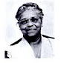
On Mother’s Day in 1946, the American Mothers organization gave Emma Clarissa Clement its “Mother of the Year” honor, the first Black woman to receive the award. Clement, the granddaughter of an escaped slave, lived in Providence, Rhode Island and came south to attend Livingstone College in Salisbury, North Carolina, where she married Rev. George Clinton Clement on May 25, 1898. Clement, 71, when she received the award, had accomplished much as a mother, civic leader, and religious educator in the state of Kentucky. As a widow, she raised four sons and three daughters, four of whom went on to become college professors. All seven of the Clement children graduated from Livingstone College, the chief institution of higher learning in the African Methodist Episcopal Zion Church. Upon winning the award, Clement accepted the honor on behalf of all Black mothers. She continued working in the state for the A.M.E. Zion Church until her passing in 1952. The American Mothers organization is an offshoot of the Golden Rule Foundation, founded by Eleanor Roosevelt, Sara Delano Roosevelt, Mamie Eisenhower, JC Penney, and Norman Vincent Peale. The organization recognizes mothers from all walks of life who have used the role to provide inspiration and instruction to the nation’s future.

Program prepared by Sandra B. Crowder,
International President

Please remit all Emma Clarissa Clement Day
financial support to the District President to be sent to
Mrs. Rosetta Dunham, Executive Director,
P.O. Box 26846 - Charlotte, NC 28221-6846

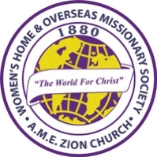
WOMEN’S HOME AND OVERSEAS
MISSIONARY SOCIETY

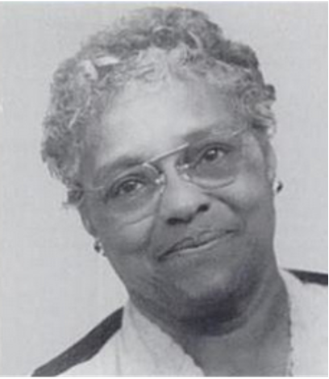
MOTHER’S DAY
May 10, 2026

“Faith that Leads, Leadership that Inspires”

Quadrennial Theme:
Reaching the Masses in an Ever-Changing World, the Journey Continues
Self-Care and Wellness, Equity and Justice,
Leadership and Legacy, Empathy and Compassion

Mrs. Sandra B. Crowder, International President
EMMA CLARISSA CLEMENT DAY
Mother’s Day/ Order of Service

The Call to Worship: And Jesus said, "Come!" To all mothers and all children: he said, "Come!" to the motherless and the childless: he said, "Come!" to all who long to be mothered: he said, "Come!

The Invocation: Gracious and loving God, we come before you today with grateful hearts, thanking you for the gift of mothers and the women who nurture, guide, and love us. As we remember Emma Clarissa Clement, whose legacy continues to shape us, bless this gathering, and fill this place with Your spirit. Honor the faith, strength, and sacrifice of mothers everywhere, and may our worship today bring glory to Your holy name. Amen!

The Opening Hymn “Faith of Our Mothers”

The Scripture Proverbs 31:26-28

The Prayer Litany
Leader: Gracious God, we thank You for mothers whose faith lights the path for generations.
People: We honor the mothers who lead with courage, compassion, and conviction.
Leader: For mothers who pray when others grow weary,
People: We thank You for their steadfast faith.
Leader: For mothers who guide their children and communities with wisdom,
People: We thank You for their inspiring leadership.
Leader: For mothers who nurture dreams and cultivate hope,
People: We thank You for their vision and perseverance.
Leader: For mothers who stand firm in the face of trials,
People: We thank You for their strength and resilience.
Leader: For mothers who teach us to walk by faith and not by sight,
People: We thank You for their example of trust in You.
Leader: For mothers who lead quietly through sacrifice and truth.
People: We celebrate their leadership that inspires.
Leader: O God, help us follow the legacy of faithful mothers—
People: To lead with integrity, and to love without condition.
Leader: May the faith of mothers continue to shape our homes, our churches, and our world.
People: And may their leadership inspire generations yet to come.
All: We give You thanks, O God, for the faith of mothers who lead and the leadership that inspires. Amen.

The Remembrance of Emma Clarissa Clement
Share historical highlights of Mrs. Emma Clarissa Clement, as the first African American woman to be named Mother of the Year. (Light a white candle and lay a white rose in front of the candle.)

The Offering The Offertory

The Introduction of the Speaker

The Song of Preparation “Somebody Prayed for Me"

The Message Speaker:
“Faith that Leads, Leadership that Inspires”

The Invitational Song “I’ve Decided to Follow Jesus”

The Call to Christian Discipleship

The Emma Clarissa Clement Recognitions:
- Select a mother to receive an Emma Clarissa Clement mother of the Year Award.
- Select mothers to receive a “Mother of Faith” Legacy Award.

The Missionary Benediction: “God be merciful unto us, and bless us, and cause His face to shine upon us, and give us peace.” Amen

