HISTORY OF ANNA L. ANDERSON DAY

Bishop William Jacob Walls stated in his book, The African Methodist Episcopal Zion Church: Reality of the Black Church “...In 1943 the [WHOMS] convention voted that October be set aside as Life Members Month in memory of Anna Lucille Anderson. It was she who in 1916 suggested the plan be adopted for the foundation of the Life Members Council.

She worked tirelessly for its salvation and fundamental rootage and watched it come to fruition in 1935 at the Convention held in Indianapolis.” The Life Members Council is designated as the Educational Arm of the Women’s Home and Overseas Missionary Society. Membership in the Council enables the Society to support the ministries on the Tree of Hope. Because of your investment and continued support, financial assistance is given to Hood Theological Seminary, Livingstone College, Clinton College, Lomax-Hannon Junior College, A.M.E. Zion University, and Hood Speaks Theological Seminary. Funds are also used to provide grants and scholarships to students attending these institutions, to pay stipends for field workers, to fund Missionary Education Leadership Training in America and overseas, and to support the general operation of the Society.

When we see and read about the contributions made by the Council, we can see how important it is for every member of Zion to become a Life Member, Honorary Life Member, Life Matron, Life Patron, or Heart for Overseas Missions supporter.

Program prepared by: Mrs. Joy Foster, Connectional LM Chairman

Please send Anna L. Anderson contributions to the District President for remittance to the WH&OMS, Mrs. Rosetta Dunham, Executive Director -P O. Box 26846, Charlotte, NC 28221



Women’s Home and Overseas Missionary Society
Anna L. Anderson Day
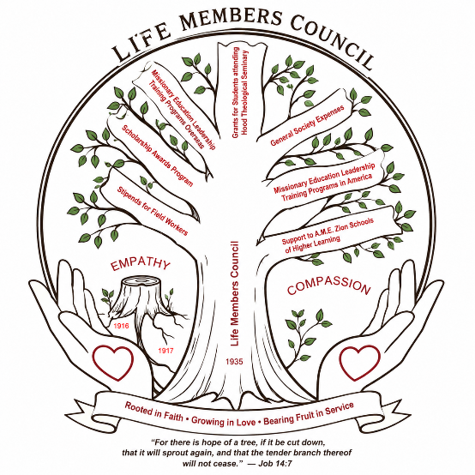
October 2026

2023 – 2027 QUADRENNIAL THEME:
“REACHING THE MASSES IN
AN EVER-CHANGING WORLD: THE JOUNEY CONTINUES!
EMPATHY AND COMPASSION

“Throwing out the Lifeline of Empathy and Compassion across the World”

Mrs. Joy Foster, Connectional Chairman,
Life Members Council
Mrs. Sandra B. Crowder, International President

Women’s Home and Overseas Missionary Society
African Methodist Episcopal Zion Church

THE CALL TO WORSHIP
Stand up, oh ye people, Stand up! The call has been given to be an example of a humble servant embracing empathy and compassion throughout the world. Lord help us to continue to reach the masses in an ever-changing world to leaving an indelible mark for generations to come. AMEN.
THE INVOCATION
Heavenly Father we invoke your presence on this day as we honor the legacy of Anna L. Anderson the visionary for the Life Members Council. Let us see through the lens of empathy and compassion allowing it to saturate this sanctuary on today and for years to come. AMEN.
THE AFFIRMATION OF FAITH
THE HYMN OF PRAISE
Traditional- “Great is Thy Faithfulness” Hymn #80 A.M.E. Zion Bicentennial Hymnal
Contemporary- “Compassion” by William Murphy
THE LITANY OF EMPATHY AND COMPASSION
Leader: The Lord is gracious and compassionate, slow to anger and rich in love. The Lord is good to all; He has compassion on all He has made. (Psalm 145:8-9)
People: Lord give us a spirit of empathy and compassion to lift up our sister or brother.
Leader: If one part suffers, every part suffers with it: If one part is honored, every part rejoices with it. (1 Corinthians 12:26)
People: Lord give us a spirit of empathy and compassion to lift up our sister or brother.
All: Lord cloth us with Empathy and Compassion to allow your spirit to be seen as a light to those who are downtrodden. Give us an empathic and compassionate spirit which resembles your teachings as we continue to reach the masses and to win the world for Christ. AMEN.
SCRIPTURE READING Lamentations 3:21-26
THE PRAYER FOR EMPATHY AND COMPASSION
Heavenly Father, we humbly come before You, seeking to cultivate a heart filled with compassion. Help us to see the world through Your eyes, embracing the struggles of others with love and understanding. May our actions reflect Your mercy, and may we be instruments of Your peace. O Father, grant us the gift of empathy, that we may see the world through the eyes of others. Help us to open our hearts to their struggles and joys, and to bear their burdens with compassion. May our love and understanding reflect Your divine grace. Amen.
THE SERMONIC SELECTION
THE MESSAGE OF EMPATHY AND COMPASSION
THE INVITATIONAL HYMN & CALL TO DISCIPLESHIP
THE ANNA L. ANDERSON DAY OFFERING APPEAL
THE MISSIONARY BENEDICTION
“God be merciful unto us and bless us; and cause His face to shine upon us and give us peace.” AMEN (Psalm 67:1)

